 | FACTSHEET 05/04  Tornado Mobile Technical Specification

Designed to be operated in a well ventilated room an EcoCooling evaporative cooler offers a versatile and effective solution to your cooling needs.  An EcoCooling Tornado evaporative cooler supplies a constant flow of naturally cooled air without the use of environmentally damaging refrigerants. Its low energy use also provides the minimum possible impact on our environment | 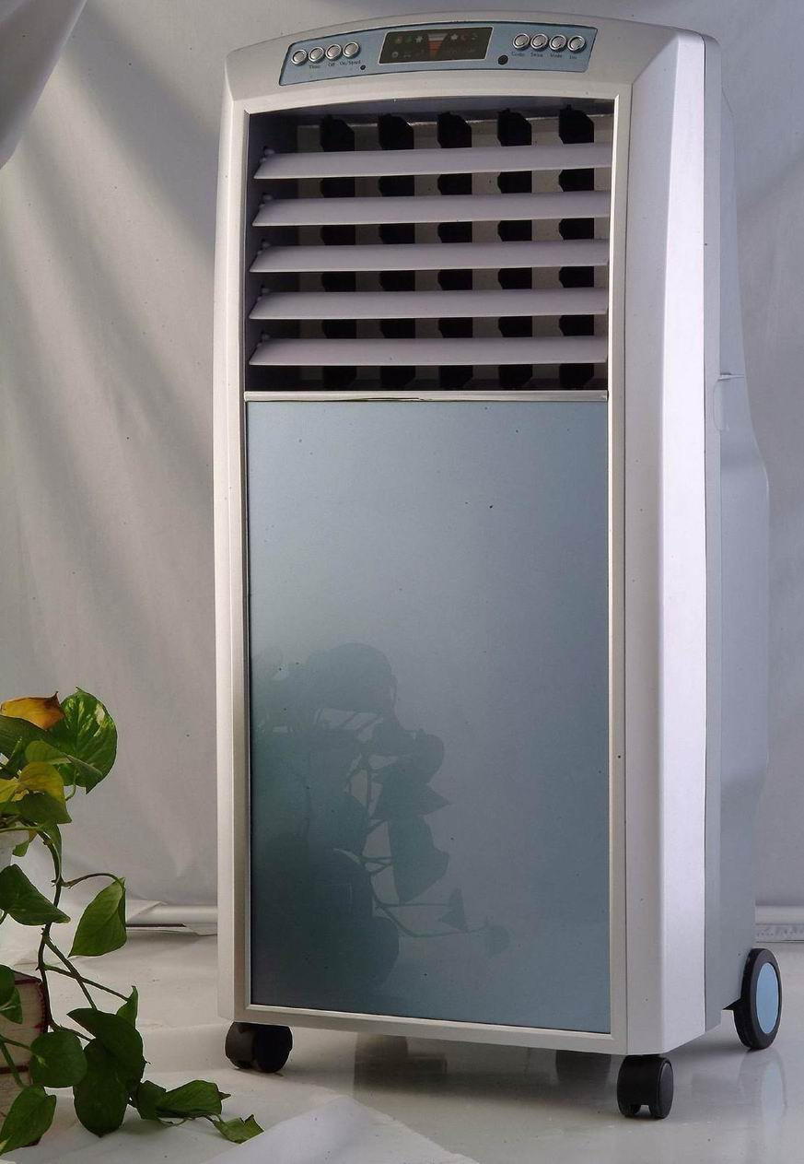
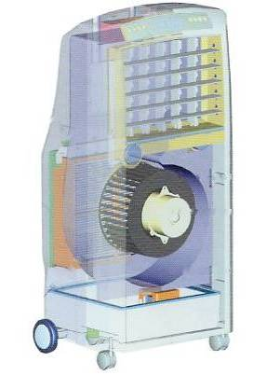 | Key Features  ► Variable fan speed: High, medium or slow speed can be selected  ► Multiple modes: Ordinary, Natural or Sleep modes available to optimise your comfort levels  ► Timer: Program you cooler to run up to 8 hours  ► Easy clean: Easy to remove and clean components allow you to maintain a hygienic and efficient cooler  ► Easy fill: Unique removable tray allows filling directly from a tap  ► Cool or Vent operation  ► Automatic louvres allow you to direct the air horizontally and vertically
Tornado Specification  Air Flow 1000 m3/hr  Power input 160W  Electrical Supply 240VAC  Operating weight 14 KG  Height 890 mm  Width 450 mm  Depth 390 mm  Noise Level 48DbA | Remote Control Easy fill water tray  