 | FACTSHEET 04/01a  ECP16000s Technical Specification

Producing a flow rate of up to 16,000m³/hr this evaporative cooler is manufactured by EcoCooling Limited in an ISO 9002 quality environment. Designed to meet all European electrical, water and other safety legislation.  CABINET: The cabinet components are injection moulded structural foam polypropylene. The cabinets are UV stabilised and corrosion free. The fan housing is manufactured from stainless steel.  COOLING PADS: Cooling pads are Munters Celdek honeycomb, saturation efficiencies in the range of 85-89 % Munters CelDek 680x850x100mm, three pads total area 1.8m² | 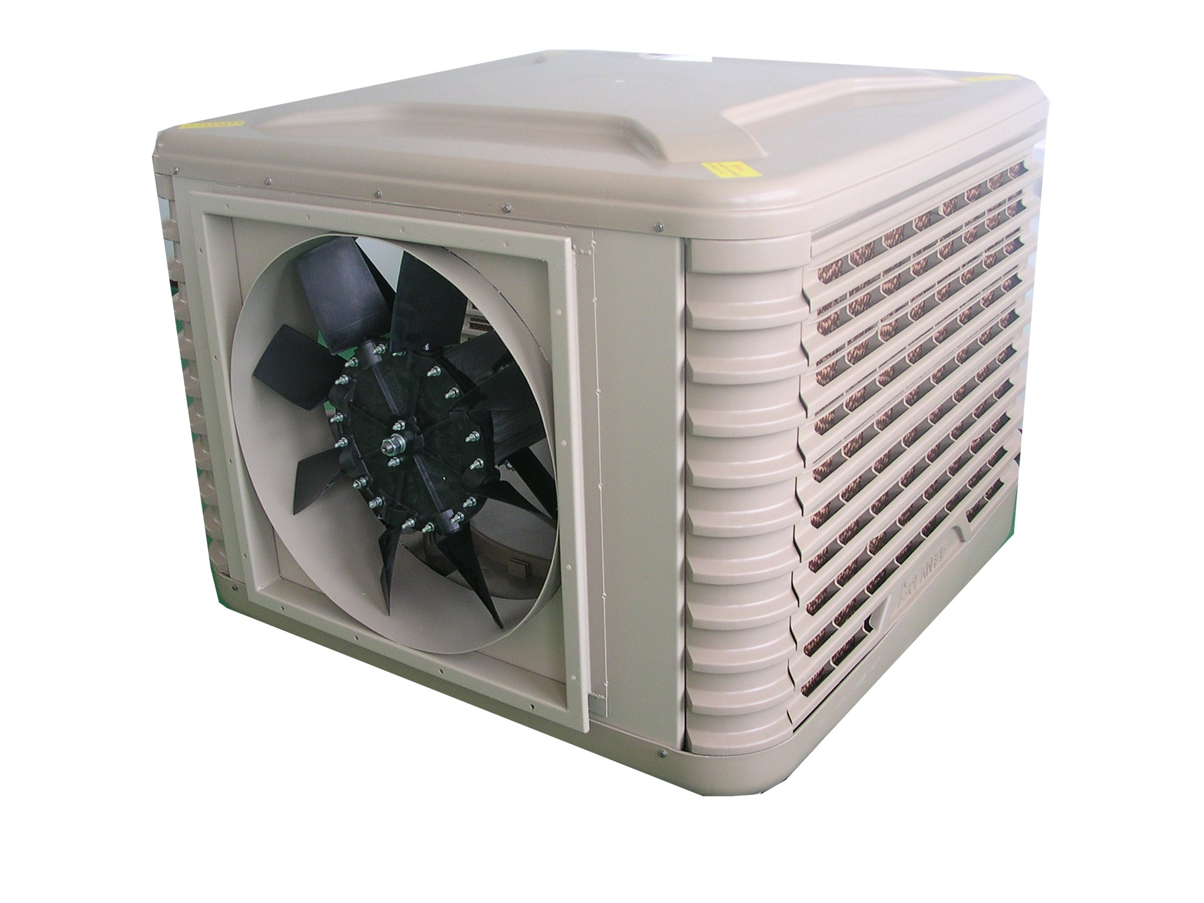
MOTOR: FAN MOTORS:
 | Variable | Two Speed
Motor Type | EVA - VS | EVA - VS
Poles | 4 | 6/12
Speed | 1340rpm | 940/600 rpm
Volts | 220V AC | 220V AC
Hz | 50 | 50
Amps Start | 12A | 8A
Amps Run | 8A | 5.6/3.5 A
Capacitor | 60F/450V | 30F/450V
Duty | S1 | S1
Ins | F | F
IP | 44 | 44
Overload | Auto Reset | Auto Reset

WATER: Supply minimum 1 bar max 7 bar. Minimum supply 500 L/hr. Sump Capacity 23L
ELECTRICAL SUPPLY: 240V 50Hz. 10A start 5A running
DRAIN: Minimum capacity 2000l/hr to an appropriate effluent point in accordance with local water regulations.
CIRCULATION PUMP: 50W, 30L/min, Centrifugal, Encapsulated, Shaded Pole Magnetically Coupled, Auto reset overload.
DIMENSIONS: Height 950mm, Length 1170mm Width 1170mm, Volume 1.3m³
WEIGHT: Dry 55Kg Operating 92kg. The cooler is designed to be supported from a plain edged vertical duct.
DUCT: Length 645mm x Width 645mm
CONTROL: Can be controlled in groups: Facility to directly connect to timer, thermostat, internal humidistat, external humidistat and fire alarm contact.
Refer to separate documentation for details.
OPTIONAL EXTRAS:
Weather seal: Automatically shuts air flow when fan is stopped
WARRANTY: Two years: parts only.

Always refer to the website www.ecocooling.org for latest specifications

